Practical No 01

Aim: To create a basic webpage using common HTML tags such as headings, paragraphs, links, images, lists, tables, and forms.

Source Code:

<!DOCTYPE html>
<html lang="en">
<head>
<title>My Basic Webpage</title>
</head>
<body>
<!-- Main Heading -->
<h1>Welcome to My Webpage</h1>
<!-- Paragraph -->
<p>
This is a basic webpage created using HTML tags.
HTML stands for HyperText Markup Language.
</p>
<hr>
<!-- About Section -->
<h2>About Me</h2>
<p>
My name is Student. I am learning web development
and exploring HTML, CSS and JavaScript.
</p>

<!-- Text Formatting -->
<h3>Text Formatting</h3>

<p>
This is <b>bold text</b>.
This is <i>italic text</i>.
This is <u>underlined text</u>.
</p>

<!-- Unordered List -->
<h2>My Hobbies</h2>

<ul>
<li>Reading</li>
<li>Programming</li>
<li>Music</li>
<li>Sports</li>
</ul>

<!-- Ordered List -->
<h2>Programming Languages</h2>

<ol>
<li>Python</li>
<li>Java</li>
<li>C++</li>
<li>JavaScript</li>
</ol>

<!-- Link -->
<h2>Useful Link</h2>

<p>
Visit
<a href="https://www.google.com" target="_blank">
Google
</a>
</p>

<!-- Table -->
<h2>Student Information</h2>

<table border="1" cellpadding="10">
<tr>
<th>Name</th>
<th>Course</th>
<th>Year</th>
</tr>

<tr>
<td>Student 1</td>
<td>Computer Science</td>
<td>Third</td>
</tr>

<tr>
<td>Student 2</td>
<td>Information Technology</td>
<td>Third</td>
</tr>
</table>

<!-- Form -->
<h2>Contact Form</h2>

<form>

<label for="name">Name:</label>
<input type="text" id="name" name="name">

<br><br>

<label for="email">Email:</label>
<input type="email" id="email" name="email">

<br><br>

<label for="message">Message:</label>
<textarea id="message" name="message"
rows="4" cols="30"></textarea>

<br><br>

<input type="submit" value="Submit">

<input type="reset" value="Reset">

</form>

<hr>

<!-- Footer -->
<footer>
<p>&copy; 2026 My Basic Webpage</p>
</footer>

</body>

</html>

Output:
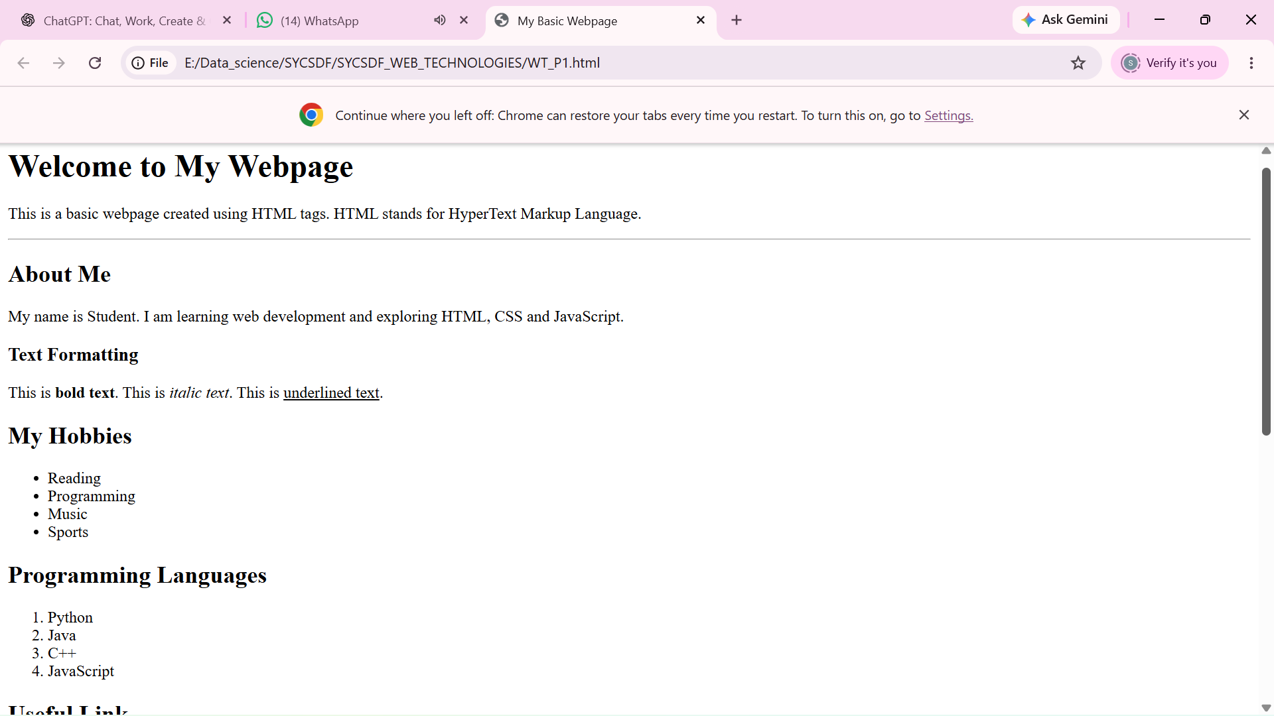
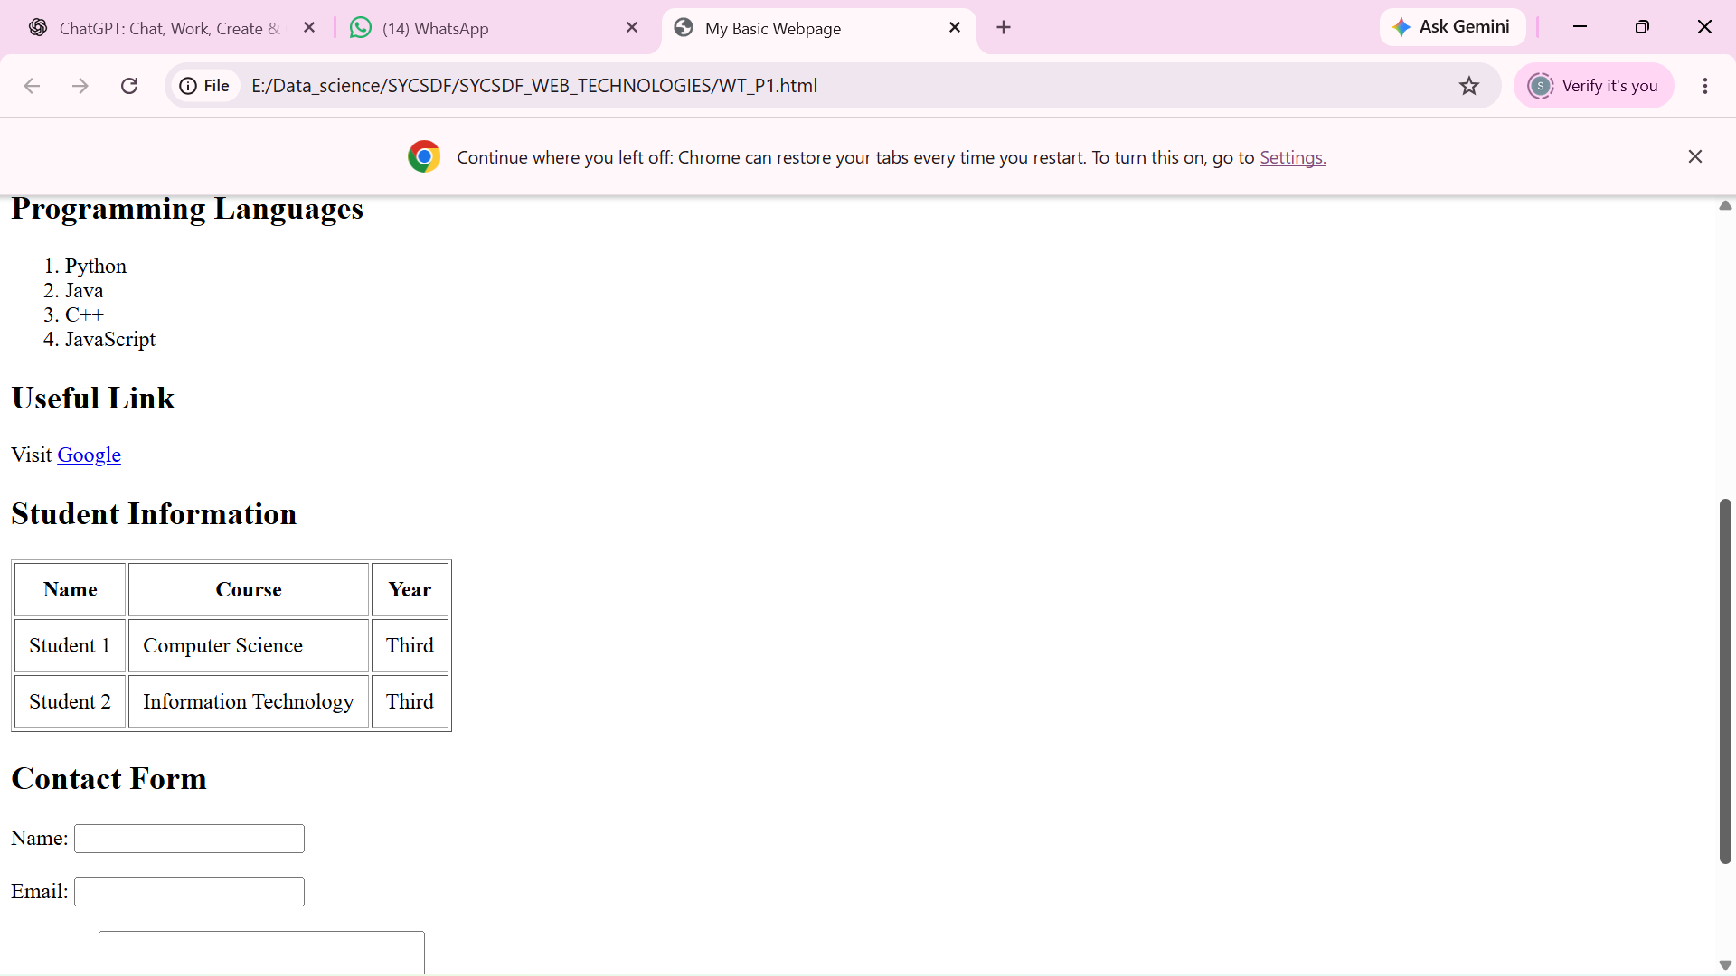
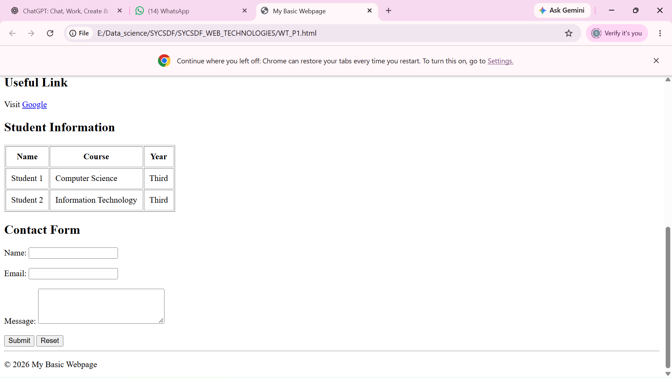

Practical No. 02
Aim: To design a student registration form using HTML form elements such as text boxes, radio buttons, checkboxes, dropdown lists, date fields, and submit/reset buttons.

Source Code:
<!DOCTYPE html>
<html lang="en">

<head>

<title>Student Registration Form</title>
</head>

<body>

<h1>Student Registration Form</h1>

<form>

<!-- Personal Information -->
<fieldset>

<legend>Personal Information</legend>

<label for="fname">First Name:</label>
<input type="text"
id="fname"
name="fname"
placeholder="Enter first name"
required>

<br><br>

<label for="lname">Last Name:</label>
<input type="text"
id="lname"
name="lname"
placeholder="Enter last name"
required>

<br><br>

<label for="dob">Date of Birth:</label>
<input type="date"
id="dob"
name="dob"
required>

<br><br>

<label>Gender:</label>

<input type="radio"
id="male"
name="gender"
value="Male">

<label for="male">Male</label>

<input type="radio"
id="female"
name="gender"
value="Female">

<label for="female">Female</label>

<input type="radio"
id="other"
name="gender"
value="Other">

<label for="other">Other</label>

</fieldset>

<br>

<!-- Contact Information -->
<fieldset>

<legend>Contact Information</legend>

<label for="email">Email:</label>
<input type="email"
id="email"
name="email"
placeholder="example@email.com"
required>

<br><br>

<label for="phone">Mobile Number:</label>
<input type="tel"
id="phone"
name="phone"
placeholder="Enter mobile number"
required>

<br><br>

<label for="address">Address:</label>
<br>

<textarea id="address"
name="address"
rows="4"
cols="40"
placeholder="Enter your address">
</textarea>

</fieldset>

<br>

<!-- Course Information -->
<fieldset>

<legend>Course Information</legend>

<label for="course">Select Course:</label>

<select id="course" name="course">

<option value="">-- Select Course --</option>
<option value="bca">BCA</option>
<option value="bsc">B.Sc.</option>
<option value="btech">B.Tech</option>
<option value="bba">BBA</option>
<option value="mca">MCA</option>

</select>

<br><br>

<label>Subjects Interested In:</label>

<br>

<input type="checkbox"
id="python"
name="subject"
value="Python">

<label for="python">Python</label>

<br>

<input type="checkbox"
id="java"
name="subject"
value="Java">

<label for="java">Java</label>

<br>

<input type="checkbox"
id="web"
name="subject"
value="Web Development">

<label for="web">Web Development</label>

<br>

<input type="checkbox"
id="ml"
name="subject"
value="Machine Learning">

<label for="ml">Machine Learning</label>

</fieldset>

<br>

<!-- Login Information -->
<fieldset>

<legend>Login Information</legend>

<label for="username">Username:</label>

<input type="text"
id="username"
name="username"
required>

<br><br>

<label for="password">Password:</label>

<input type="password"
id="password"
name="password"
required>

<br><br>

<label for="confirm">Confirm Password:</label>

<input type="password"
id="confirm"
name="confirm"
required>

</fieldset>

<br>

<!-- Buttons -->

<input type="submit" value="Register">

<input type="reset" value="Reset">

</form>

</body>

</html>

Output:

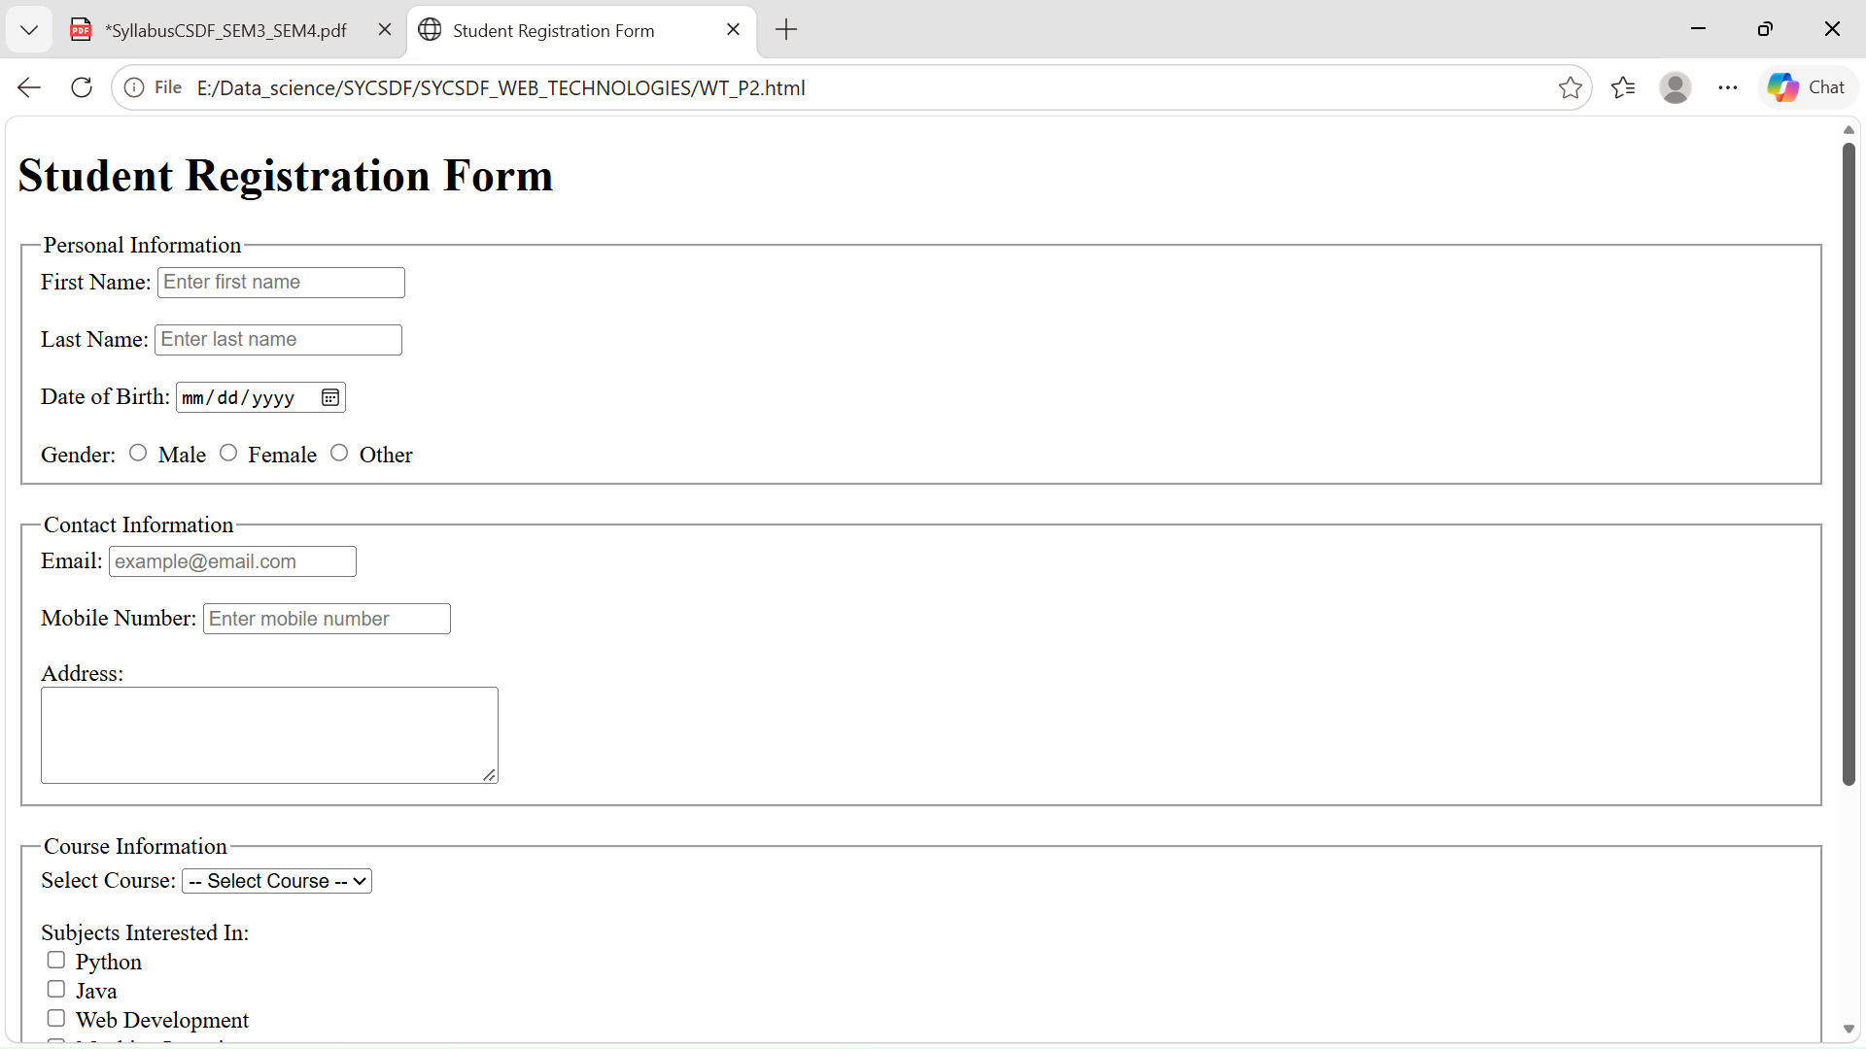

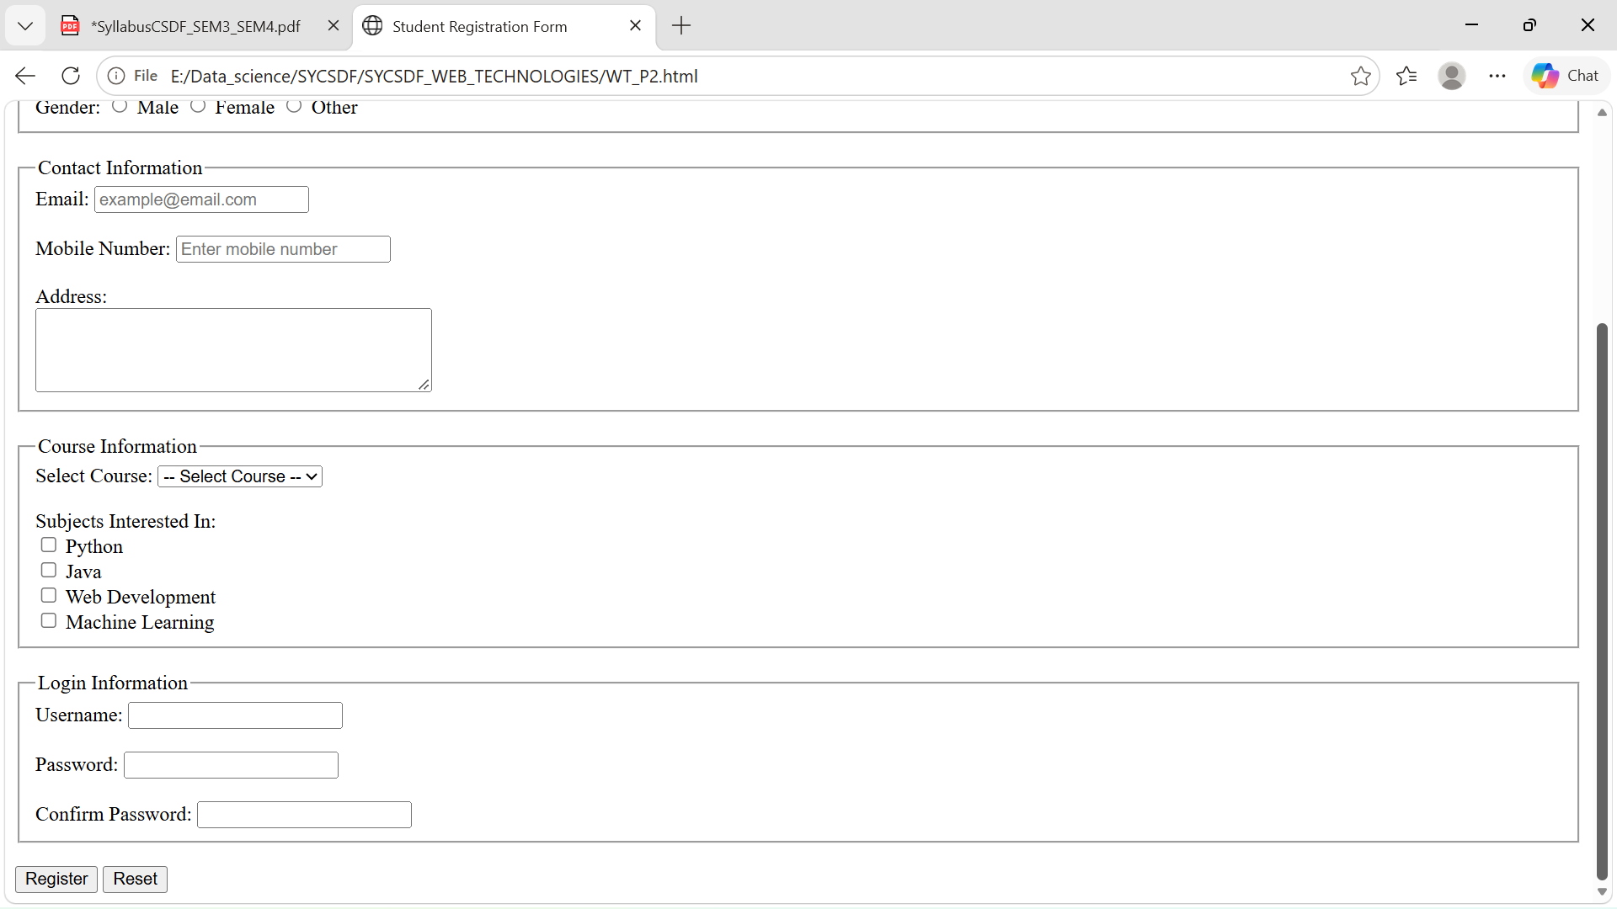

Practical No 03
Aim: To design and style a webpage using both Internal CSS and External CSS.

For this practical, create two files:

index.html — HTML webpage with internal CSS.
style.css — external stylesheet.

Source Code:

1. HTML File — index.html

<!DOCTYPE html>
<html>
<head>
<title>My Webpage</title>

<!-- External CSS -->
<link rel="stylesheet" href="style.css">

<!-- Internal CSS -->
<style>
h1 {
color: darkblue;
text-align: center;
}

.intro {
color: darkgreen;
font-size: 18px;
text-align: center;
}
</style>
</head>

<body>

<header>
<h1>Welcome to My Website</h1>
<p class="intro">This is a simple webpage using CSS.</p>
</header>

<div class="box">
<h2>About Us</h2>
<p>
We create simple and attractive webpages using HTML and CSS.
</p>
<button>Learn More</button>
</div>

<footer>
<p>© 2026 My Website</p>
</footer>

</body>
</html>

2. s1.css

/* --------------------------------------------------
External CSS File
-------------------------------------------------- */

body {
background-color: pink;
font-family: Arial, sans-serif;
text-align: center;
}

button {
background-color: red;
color: green;
padding: 10px 20px;
border: none;
border-radius: 5px;
}

Output:

Output:
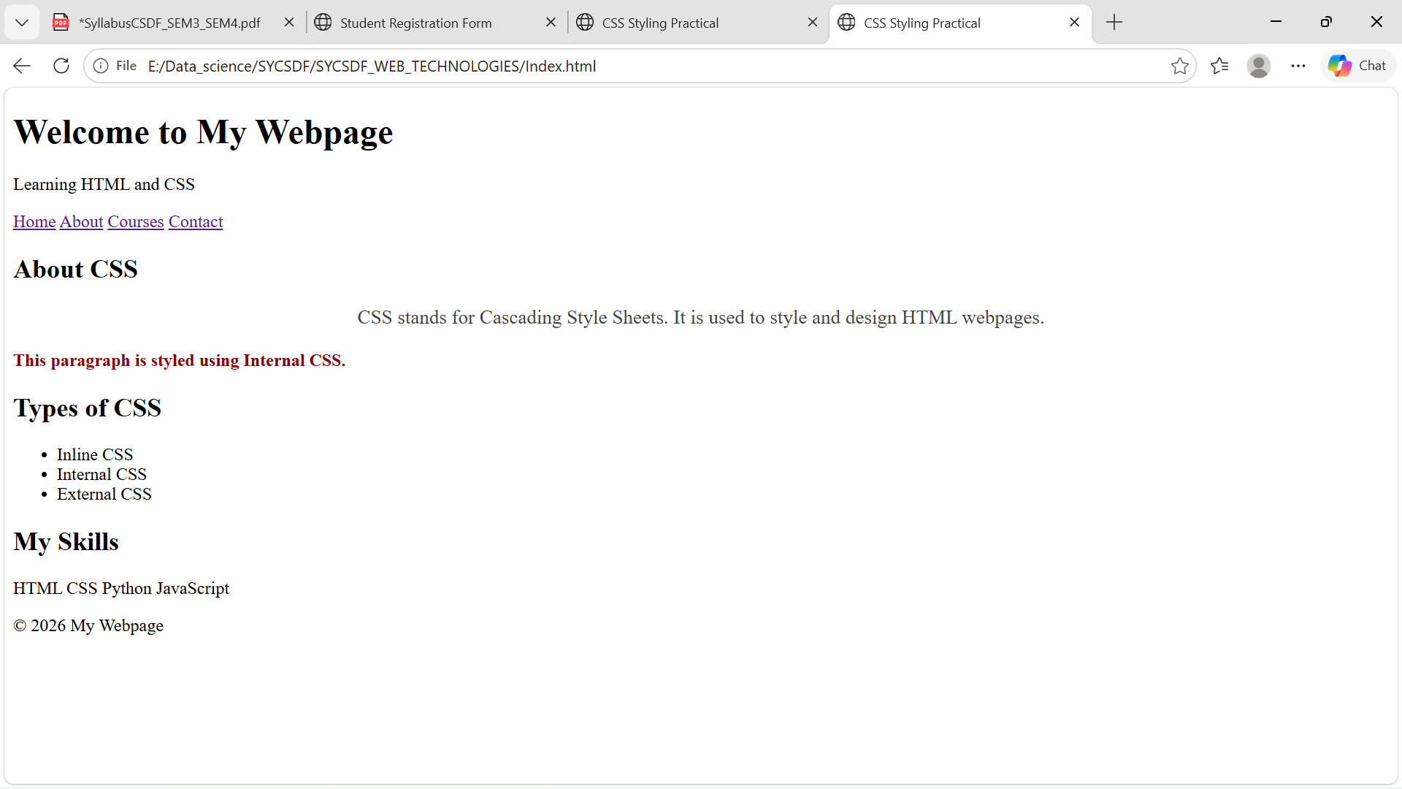

Practical No 04

Aim : To create a responsive-style navigation menu using HTML and CSS, with hover effects and a dropdown-style menu.

Source Code:

<!DOCTYPE html>
<html lang="en">

<head>
<title>Navigation Menu</title>
<style>

/* Page */
body {
font-family: Arial, sans-serif;
background-color: #f2f2f2;
}

/* Navigation Bar */
nav {
background-color: #1e293b;
padding: 0 30px;
}

/* Main Menu */
.menu {
list-style: none;
display: flex;
justify-content: center;
}

.menu > li {
position: relative;
}

.menu > li > a {
display: block;
color: white;
text-decoration: none;
padding: 18px 25px;
font-size: 17px;
}

/* Hover Effect */
.menu > li > a:hover {
background-color: #2563eb;
}

/* Dropdown Menu */
.dropdown {
display: none;
position: absolute;
top: 100%;
left: 0;
min-width: 180px;
background-color: #1e293b;
list-style: none;
z-index: 1000;
}

.dropdown li a {
display: block;
color: white;
text-decoration: none;
padding: 12px 18px;
}

</style>

</head>

<body>

<!-- Navigation Menu -->
<nav>

<ul class="menu">

<li>
<a href="#">Home</a>
</li>

<li>
<a href="#">About</a>
</li>

<li>
<a href="#">Courses ▾</a>

<ul class="dropdown">

<li>
<a href="#">Web Development</a>
</li>

<li>
<a href="#">Python</a>
</li>

<li>
<a href="#">Machine Learning</a>
</li>

</ul>
</li>
<li>
<a href="#">Services</a>
</li>
<li>
<a href="#">Contact</a>
</li>
</ul>
</nav>
<!-- Main Content -->
<div class="content">

<h1>Welcome to My Website</h1>

<p>
Use the navigation menu above to explore the website.
</p>
</div>
</body>
</html>

Output:

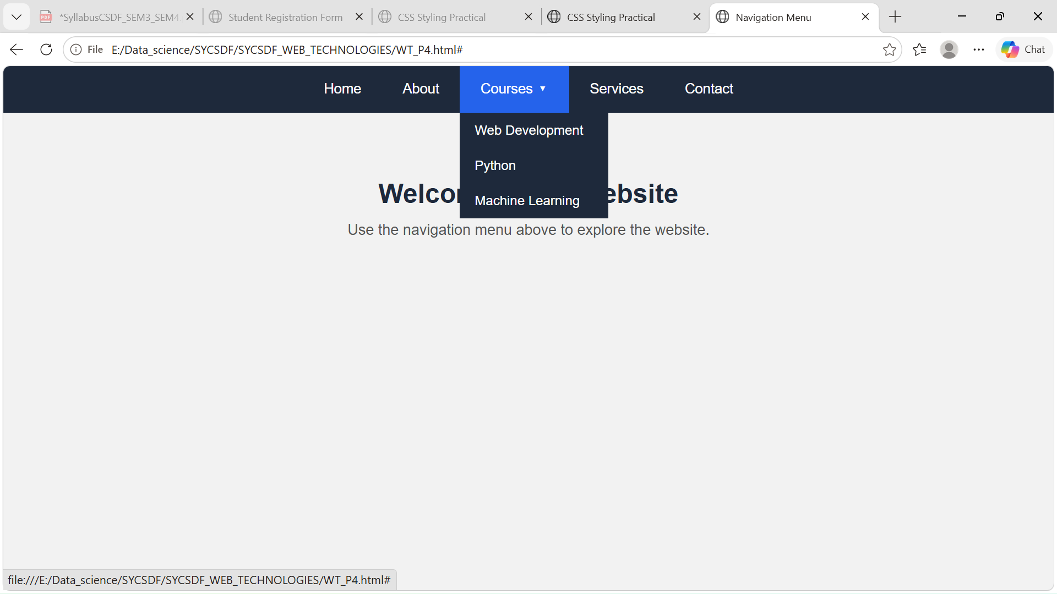

Practical No. 05
Aim:To create a responsive webpage layout using CSS Flexbox that automatically adjusts its arrangement for different screen sizes.

Source Code:

<!DOCTYPE html>
<html lang="en">

<head>
<title>Responsive Flexbox Layout</title>

<style>

body {
font-family: Arial, sans-serif;
background-color: #f1f5f9;
color: #222;
}
/* -----------------------------
Header
------------------------------ */
header {
background-color: #2563eb;
color: white;
padding: 25px;
text-align: center;
}
header h1 {
margin-bottom: 8px;
}

/* -----------------------------
Navigation
------------------------------ */

nav {
background-color: #1e293b;
}

.nav-container {
display: flex;
justify-content: center;
align-items: center;
gap: 30px;
padding: 15px;
}

/* -----------------------------
Main Flexbox Container
------------------------------ */

.container {
display: flex;

flex-wrap: wrap;

gap: 20px;

width: 90%;

max-width: 1200px;

margin: 30px auto;
}
/* -----------------------------
Main Content
------------------------------ */

.main-content {
flex: 3;

min-width: 300px;

background-color: white;

padding: 25px;

border-radius: 10px;

box-shadow:
0 3px 10px rgba(0, 0, 0, 0.1);
}

.main-content h2 {
color: #2563eb;

margin-bottom: 15px;
}

/* -----------------------------
Sidebar
------------------------------ */

.sidebar {
flex: 1;

min-width: 220px;

background-color: #dbeafe;

padding: 25px;

border-radius: 10px;
}

.sidebar h2 {
color: #1e40af;

margin-bottom: 15px;
}

.sidebar ul {
list-style: none;
}
.sidebar li {
padding: 10px;
margin-bottom: 8px;
background-color: white;
border-radius: 5px;
}
/* -----------------------------
Cards
------------------------------ */
.cards {
display: flex;
flex-wrap: wrap;
gap: 20px;
margin-top: 25px;
}
.card h3 {
color: #1d4ed8;
margin-bottom: 10px;
}
/* -----------------------------
Footer
------------------------------ */
footer {
background-color: #1e293b;
color: white;
text-align: center;
padding: 20px;

margin-top: 30px;
}

/* -----------------------------
Responsive Design
------------------------------ */

@media (max-width: 768px) {

.nav-container {
flex-direction: column;

gap: 15px;
}

.container {
flex-direction: column;
}

.main-content,
.sidebar {
width: 100%;
}

}

</style>

</head>

<body>

<!-- Header -->

<header>

<h1>My Responsive Website</h1>

<p>Built using CSS Flexbox</p>

</header>

<!-- Navigation -->

<nav>

<div class="nav-container">

<a href="#">Home</a>

<a href="#">About</a>

<a href="#">Courses</a>

<a href="#">Services</a>

<a href="#">Contact</a>

</div>

</nav>

<!-- Main Layout -->

<div class="container">

<!-- Main Content -->

<main class="main-content">

<h2>Welcome</h2>

<p>
This webpage demonstrates a responsive layout
using CSS Flexbox. The layout automatically
adjusts according to the screen size.
</p>

<!-- Cards -->

<div class="cards">

<div class="card">

<h3>HTML</h3>

<p>
HTML is used to create the structure
of webpages.
</p>

</div>

<div class="card">

<h3>CSS</h3>

<p>
CSS is used to style and design
webpages.
</p>

</div>

<div class="card">

<h3>JavaScript</h3>

<p>
JavaScript adds interactivity
to webpages.
</p>

</div>

</div>

</main>

<!-- Sidebar -->

<aside class="sidebar">

<h2>Quick Links</h2>

<ul>

<li>Web Development</li>

<li>Python Programming</li>

<li>Machine Learning</li>

<li>Data Science</li>

</ul>

</aside>

</div>

<!-- Footer -->

<footer>

<p>
&copy; 2026 My Responsive Website
</p>

</footer>

</body>

</html>

Output:

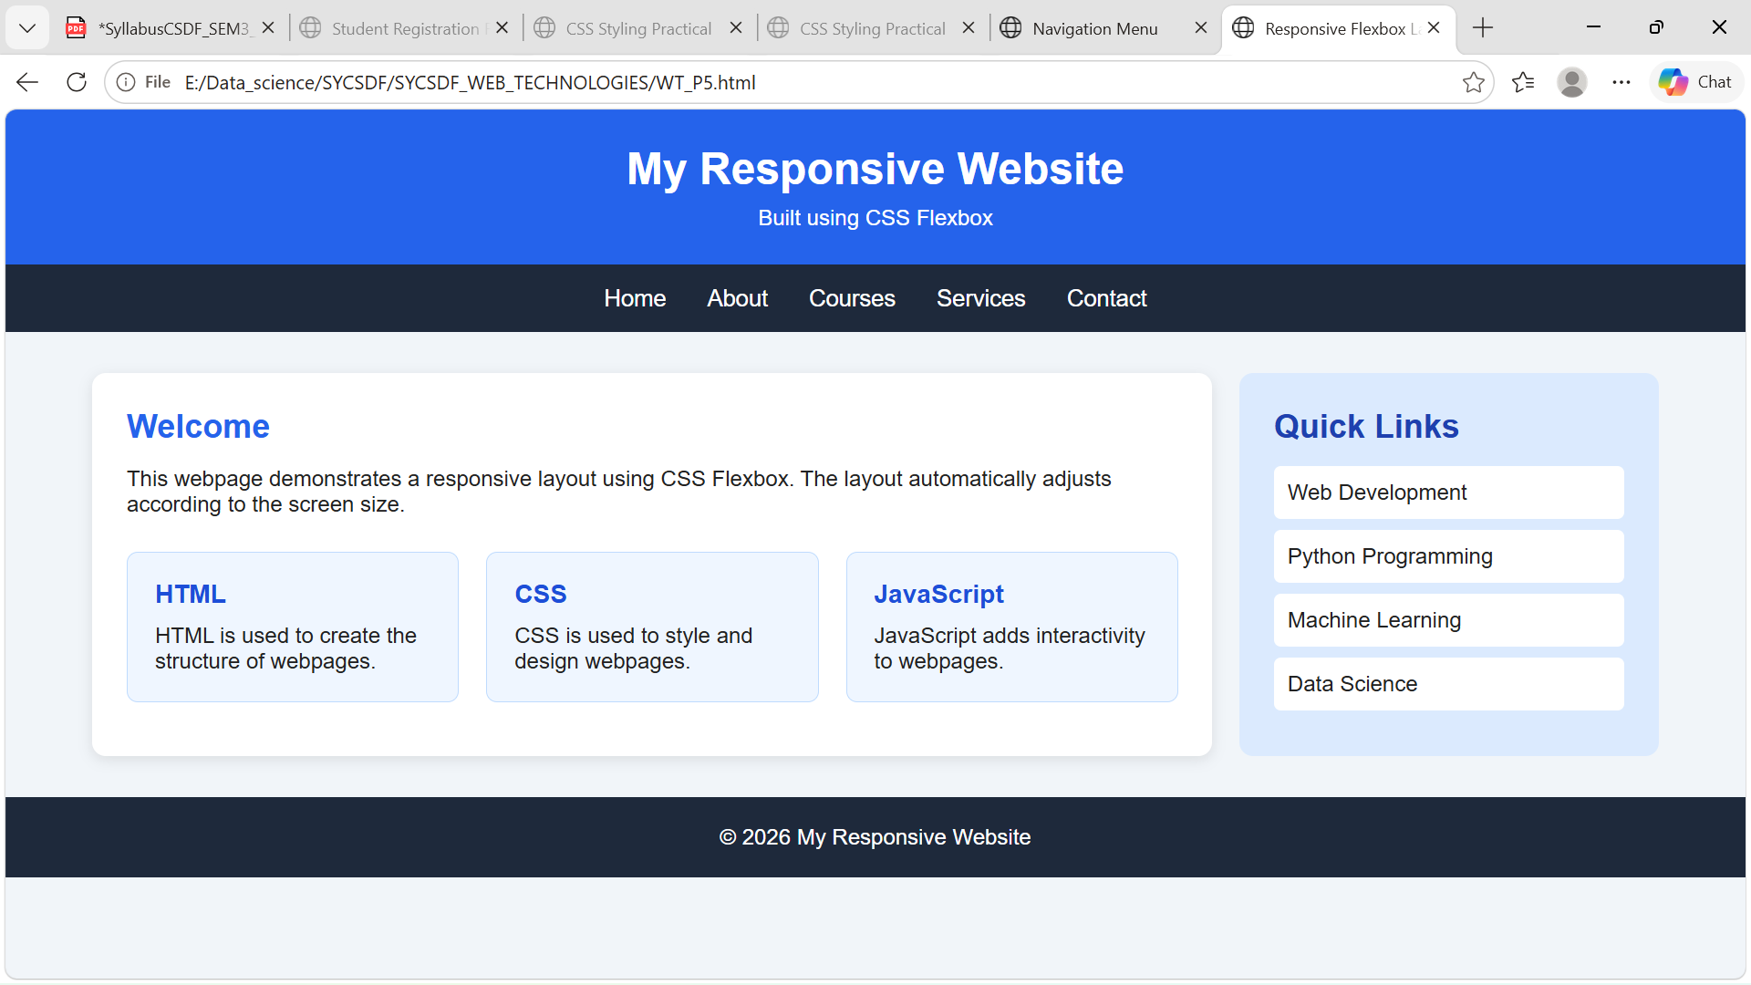
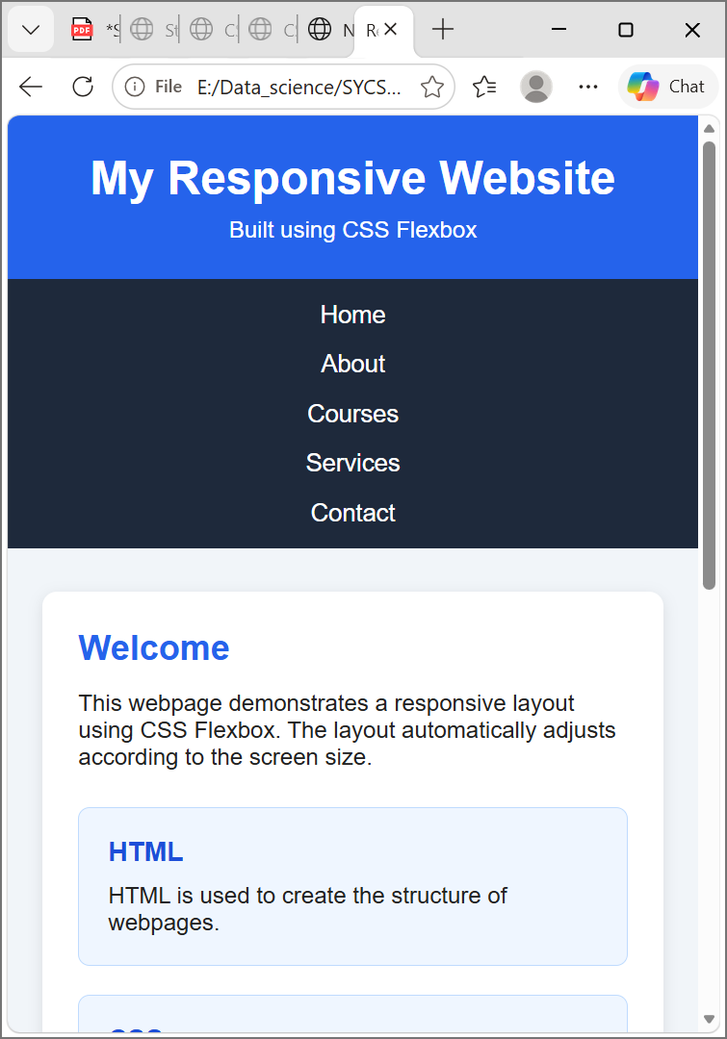
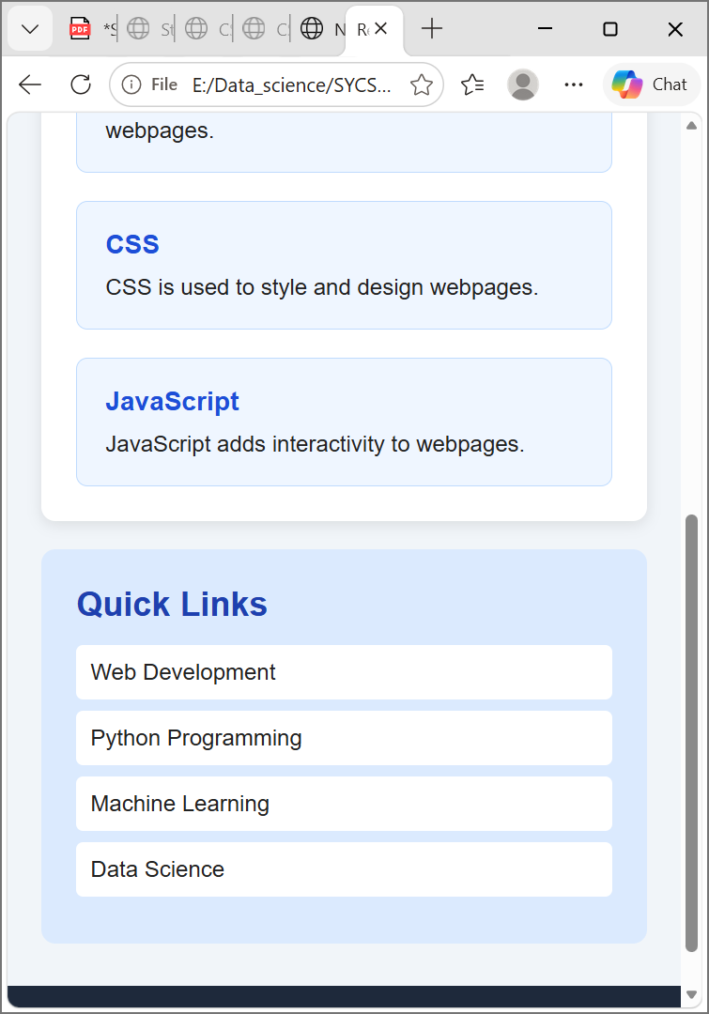

Practical No 06
Aim:To create a webpage containing images, audio, video, and hyperlinks using HTML5 multimedia and anchor tags.

Source Code:

<!DOCTYPE html>
<html lang="en">
<head>
<title>Multimedia Webpage</title>

<style>

body {
font-family: Arial, sans-serif;
background-color: #f2f6fa;
margin: 0;
text-align: center;
}

header {
background-color: #2563eb;
color: white;
padding: 25px;
}

section {
background-color: white;
width: 80%;
max-width: 800px;
margin: 25px auto;
padding: 25px;
border-radius: 10px;
box-shadow: 0 3px 10px rgba(0, 0, 0, 0.15);
}

img {
width: 400px;
max-width: 100%;
border-radius: 10px;
}

audio,
video {
width: 100%;
max-width: 600px;
}
a {
color: #2563eb;
text-decoration: none;
font-weight: bold;
}

a:hover {
text-decoration: underline;
}

footer {
background-color: #1e293b;
color: white;
padding: 20px;
}

</style>
</head>
<body>
<!-- Header -->
<header>
<h1>Multimedia Webpage</h1>
<p>Images, Audio, Video and Links using HTML</p>
</header>

<!-- Image Section -->

<section>
<h2>Image</h2>
<img src="image.jpg"
alt="Sample Image">
<p>
This image is added using the HTML
<code>&lt;img&gt;</code> tag.
</p>
</section>
<!-- Audio Section -->
<section>
<h2>Audio</h2>
<audio controls>
<source src="audio.mp3"
type="audio/mpeg">

Your browser does not support
the audio element.

</audio>

<p>
The audio player is created using
the HTML5 <code>&lt;audio&gt;</code> tag.
</p>

</section>

<!-- Video Section -->

<section>

<h2>Video</h2>

<video controls>

<source src="video.mp4"
type="video/mp4">

Your browser does not support
the video element.

</video>

<p>
The video player is created using
the HTML5 <code>&lt;video&gt;</code> tag.
</p>

</section>

<!-- Links Section -->

<section>

<h2>Useful Links</h2>

<p>
Visit
<a href="https://www.google.com"
target="_blank">
Google
</a>
</p>

<p>
Visit
<a href="https://www.wikipedia.org"
target="_blank">
Wikipedia
</a>
</p>

<p>
<a href="mailto:example@email.com">
Send an Email
</a>
</p>

</section>

<!-- Footer -->

<footer>

<p>
&copy; 2026 Multimedia Webpage
</p>

</footer>

</body>

</html>

Output:

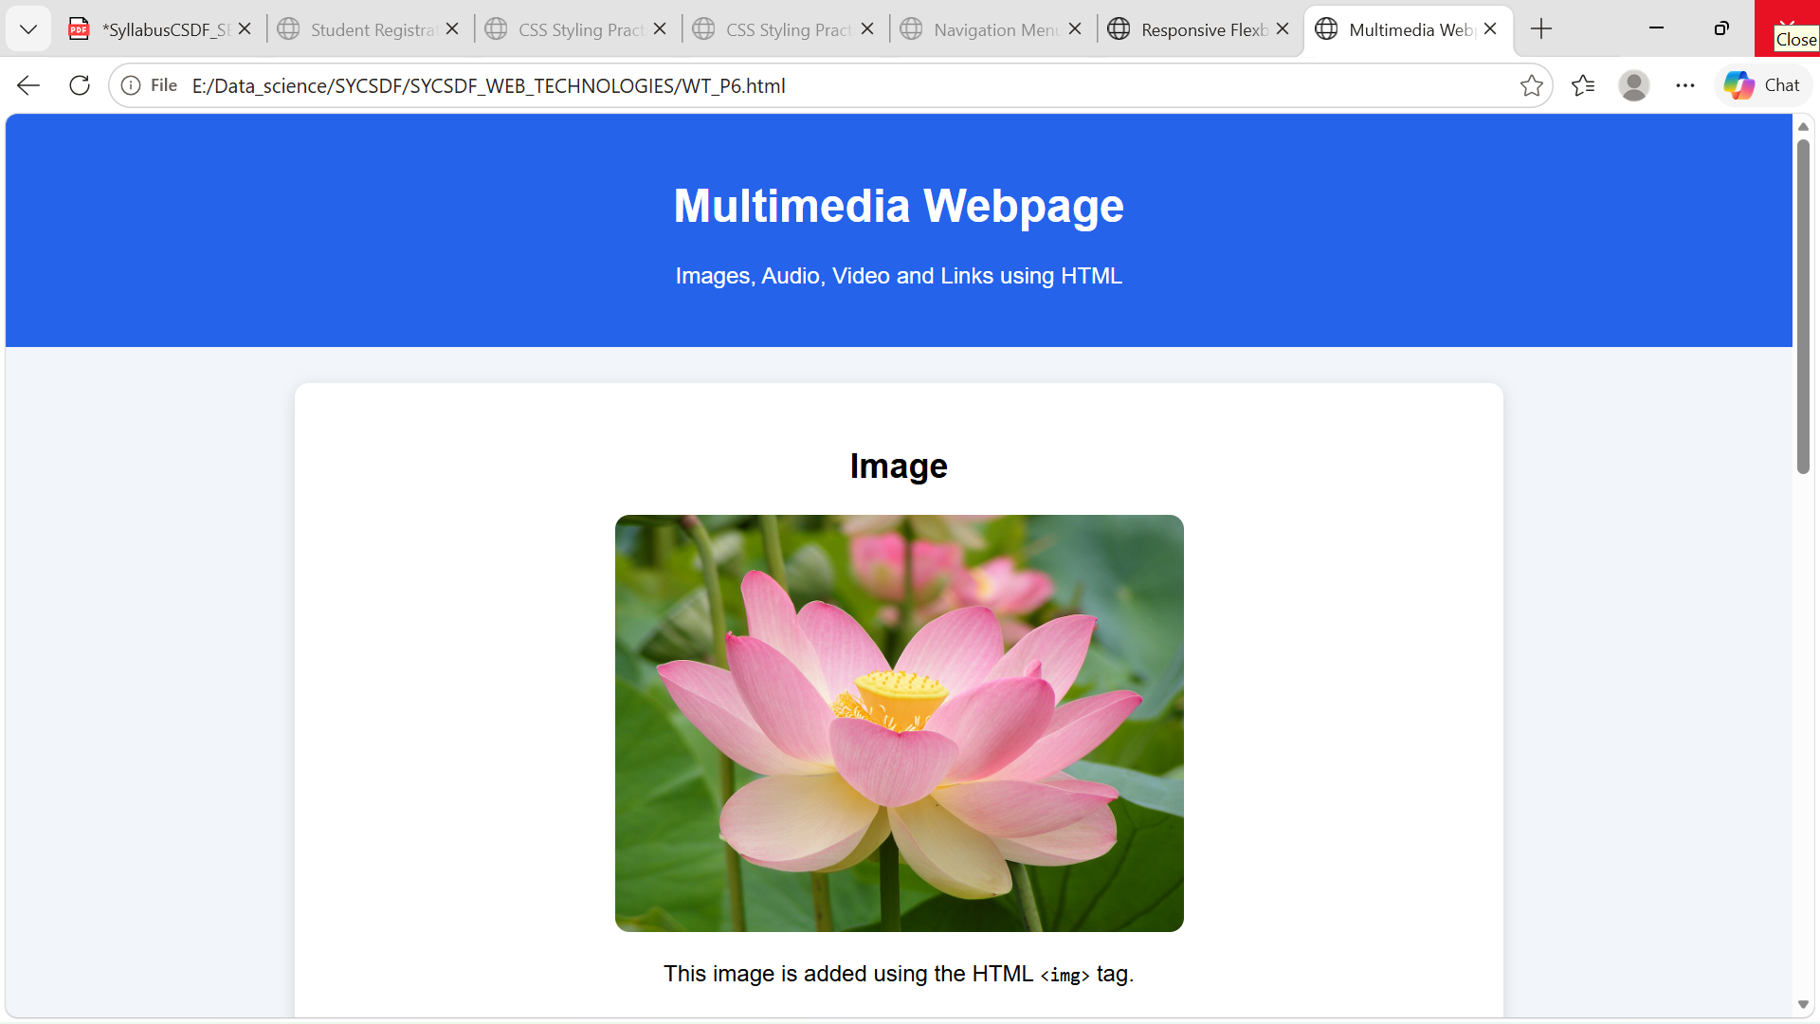
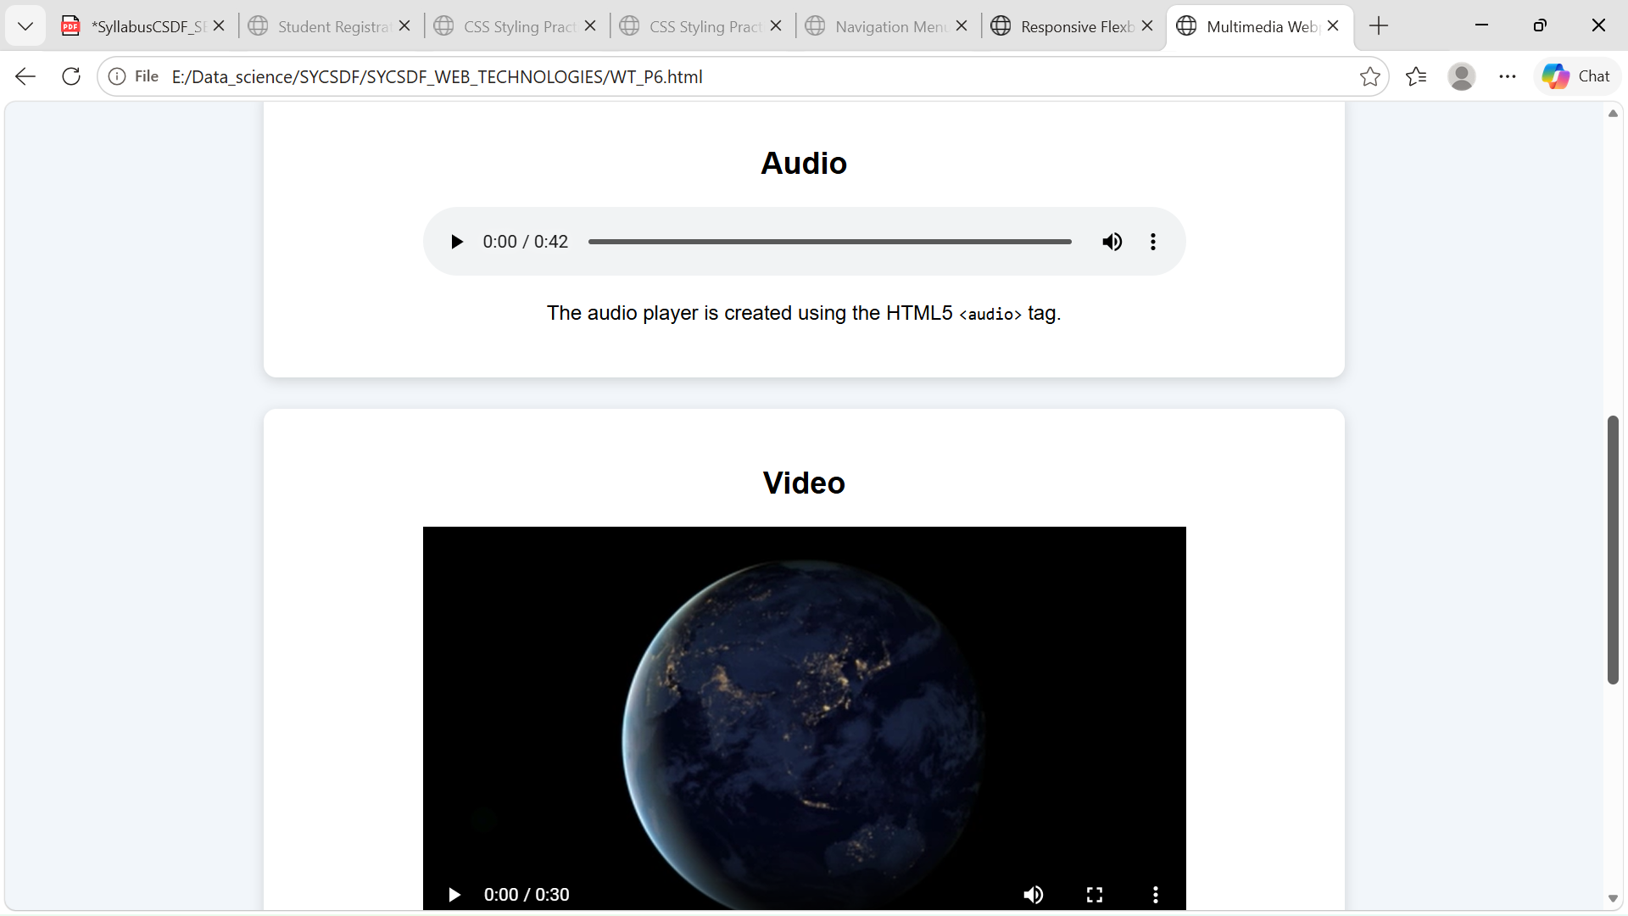
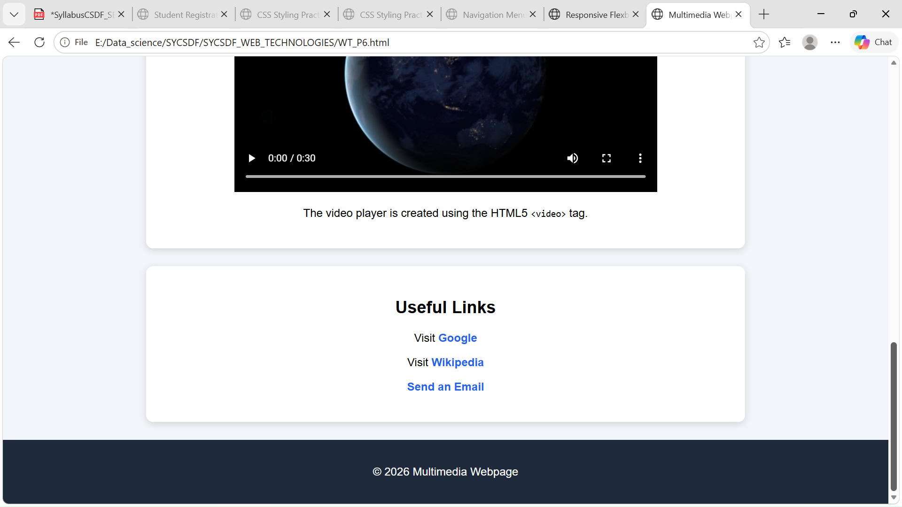

Practical 07
Aim:To write a JavaScript program to validate an HTML form by checking fields such as name, email, mobile number, password, and confirm password.

Source Code:

<!DOCTYPE html>
<html lang="en">
<head>
<title>JavaScript Form Validation</title>
<style>
body {
font-family: Arial, sans-serif;
background-color: #f2f6fa;
}
.form-container {
width: 400px;
max-width: 90%;
margin: 50px auto;
padding: 25px;
background-color: white;
border-radius: 10px;
box-shadow: 0 3px 10px rgba(0, 0, 0, 0.2);
}

h1 {
text-align: center;
color: #2563eb;
}

label {
display: block;
margin-top: 15px;
font-weight: bold;
}

input {
width: 100%;
padding: 10px;
margin-top: 5px;
box-sizing: border-box;
}

button {
width: 100%;
padding: 12px;
margin-top: 20px;
background-color: #2563eb;
color: white;
border: none;
cursor: pointer;
}

button:hover {
background-color: #1d4ed8;
}
#message {
margin-top: 15px;
text-align: center;
font-weight: bold;
}
</style>
</head>
<body>
<div class="form-container">
<h1>Registration Form</h1>
<form id="registrationForm">
<label for="name">Name:</label>
<input type="text" id="name"
placeholder="Enter your name">
<label for="email">Email:</label>
<input type="text"
id="email"
placeholder="Enter your email">
<label for="mobile">Mobile Number:</label>

<input type="text"
id="mobile"
placeholder="Enter 10-digit mobile number">
<label for="password">Password:</label>
<input type="password"
id="password"
placeholder="Enter password">
<label for="confirmPassword">
Confirm Password:
</label>

<input type="password"
id="confirmPassword"
placeholder="Confirm password">

<button type="submit">
Register
</button>

</form>

<div id="message"></div>

</div>

<script>

// Get form and message elements
const form = document.getElementById(
"registrationForm"
);

const message = document.getElementById(
"message"
);

// Form submit event
form.addEventListener("submit", function(event) {

// Prevent form submission
event.preventDefault();

// Get input values
const name = document.getElementById(
"name"
).value.trim();

const email = document.getElementById(
"email"
).value.trim();

const mobile = document.getElementById(
"mobile"
).value.trim();

const password = document.getElementById(
"password"
).value;

const confirmPassword =
document.getElementById(
"confirmPassword"
).value;

// Email pattern
const emailPattern =
/^[^\s@]+@[^\s@]+\.[^\s@]+$/;

// Mobile number pattern
const mobilePattern =
/^[0-9]{10}$/;

// Clear previous message
message.textContent = "";

// Validate Name
if (name === "") {
message.textContent =
"Please enter your name.";
message.style.color = "red";
return; }
// Validate Email
if (!emailPattern.test(email)) {
message.textContent =
"Please enter a valid email address.";
message.style.color = "red";
return;
}
// Validate Mobile Number
if (!mobilePattern.test(mobile)) {

message.textContent =
"Mobile number must contain 10 digits.";

message.style.color = "red";
return;
}
// Validate Password
if (password.length < 6) {
message.textContent =
"Password must contain at least 6 characters.";
message.style.color = "red";
return;
}
// Validate Confirm Password
if (password !== confirmPassword) {
message.textContent =
"Passwords do not match.";
message.style.color = "red";
return;
}
// Successful validation
message.textContent =
"Registration successful!";
message.style.color = "green";
// Clear form
form.reset();
});

</script>
</body>
</html>

Output:

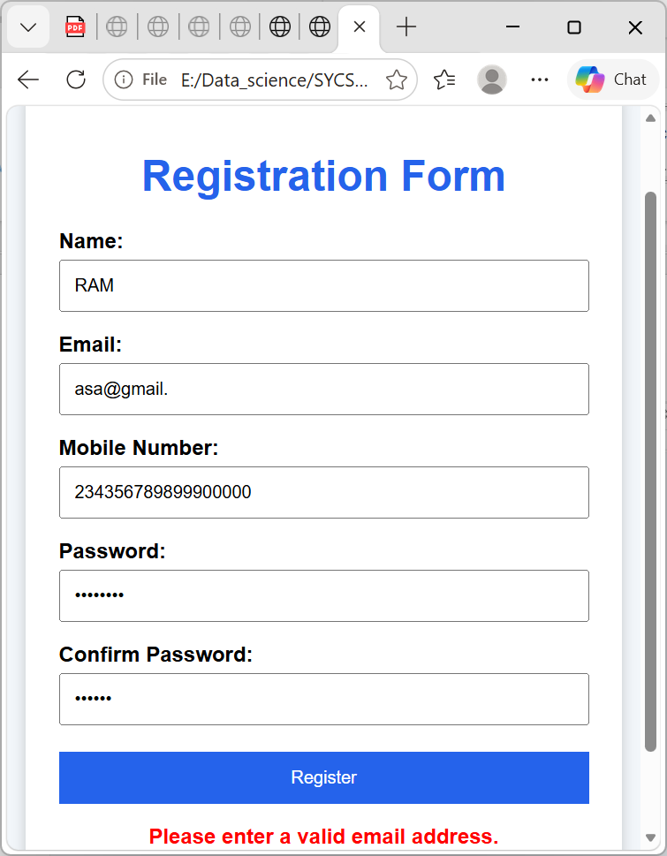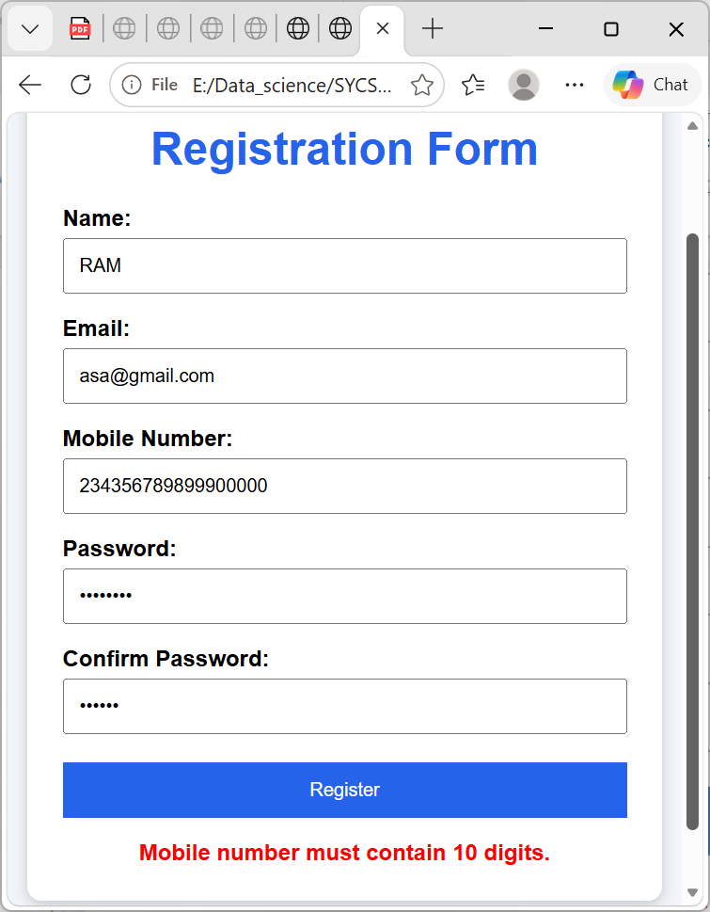

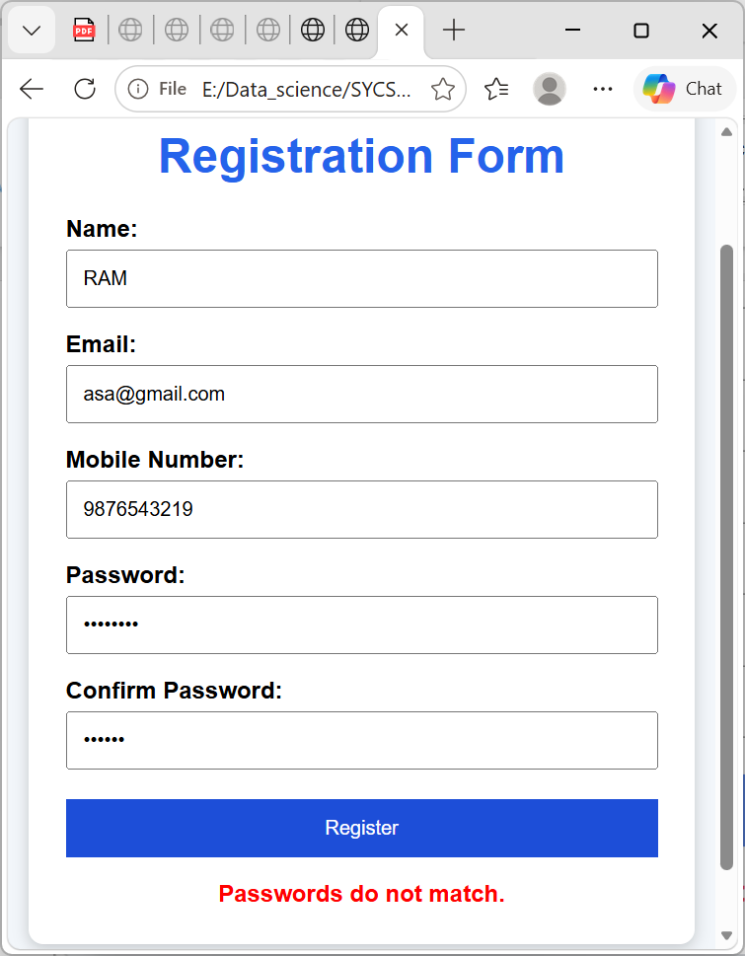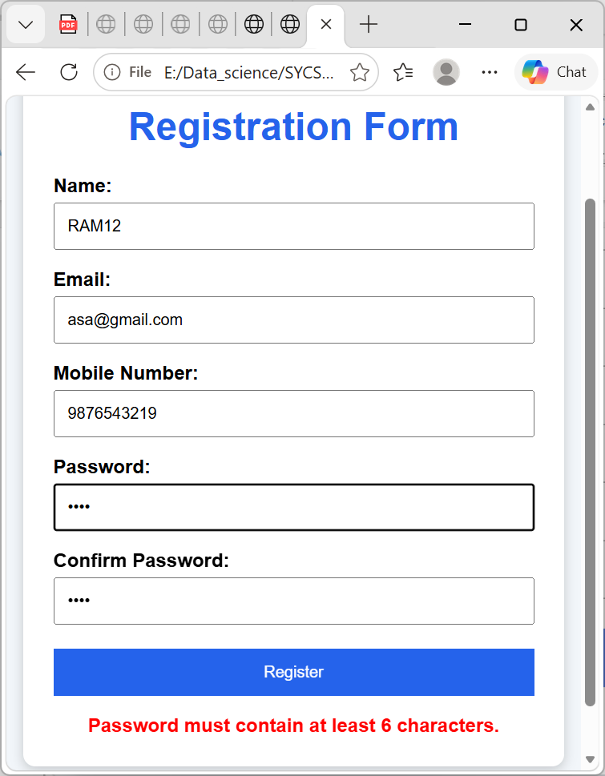
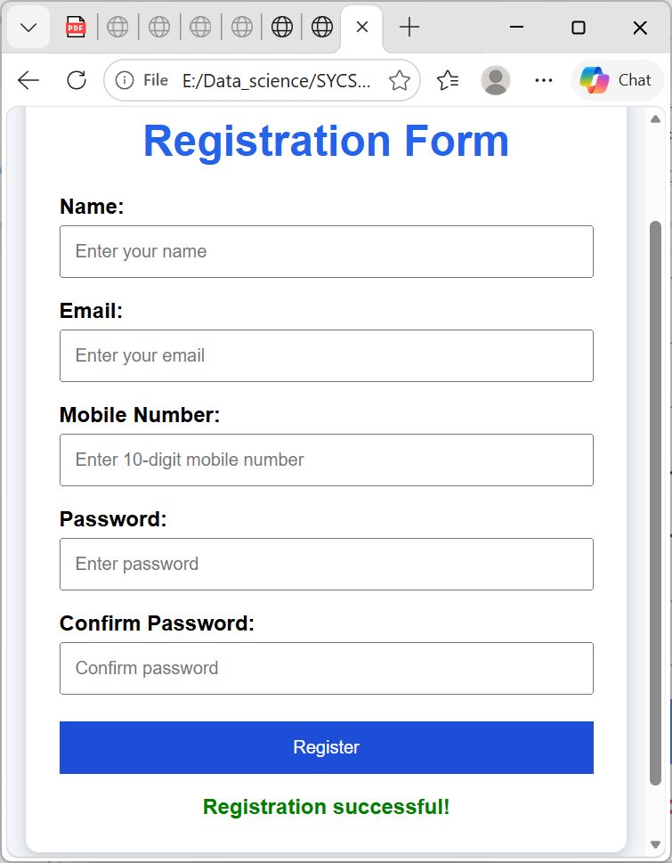

Practical No 09
Aim: To perform basic DOM (Document Object Model) manipulation using JavaScript, such as showing and hiding text when a button is clicked.

Source Code:

<!DOCTYPE html>
<html lang="en">
<head>
<title>DOM Manipulation</title>
<style>
body {
font-family: Arial, sans-serif;
text-align: center;
background-color: #f2f6fa;
padding: 50px;
}
.container {
background-color: white;
width: 500px;
max-width: 90%;
margin: auto;
padding: 30px;
border-radius: 10px;
box-shadow: 0 3px 10px rgba(0, 0, 0, 0.2);
}

h1 {
color: #2563eb;
}

#text {
margin: 20px 0;
font-size: 18px;
color: #333;
}

button {
padding: 10px 20px;
margin: 5px;
border: none;
border-radius: 5px;
color: white;
cursor: pointer;
font-size: 16px;
}

.show-btn {
background-color: #16a34a;
}

.hide-btn {
background-color: #dc2626;
}

button:hover {
opacity: 0.85;
}
</style>
</head>
<body>
<div class="container">
<h1>DOM Manipulation</h1>
<p id="text">
This is a paragraph controlled using JavaScript DOM
manipulation.
</p>

<button class="show-btn"
onclick="showText()">
Show Text
</button>
<button class="hide-btn"
onclick="hideText()">
Hide Text
</button>
</div>
<script>
// Function to show text
function showText() {
document.getElementById("text")
.style.display = "block";
}
// Function to hide text
function hideText() {
document.getElementById("text")
.style.display = "none";
}
</script>
</body>
</html>

Output:
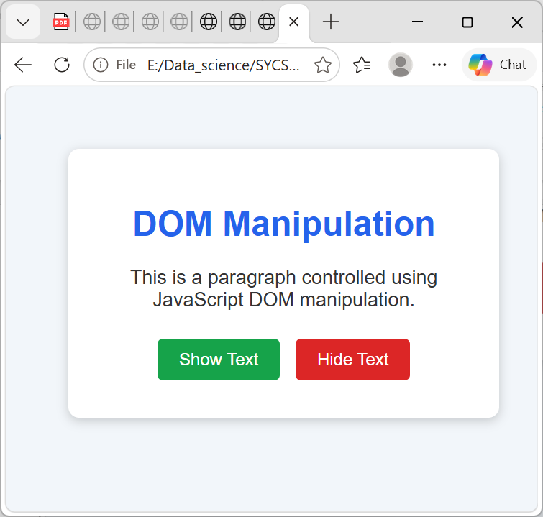

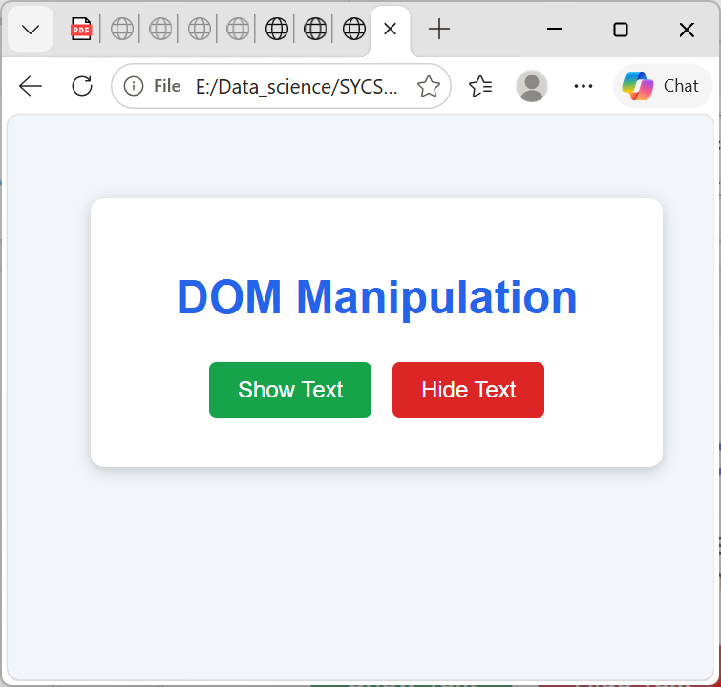

Practical No. 09
Aim:To upload a static HTML/CSS/JavaScript website to GitHub and host it online using GitHub Pages.

Requirements:
GitHub account
A website containing index.html
Internet connection
Web browser

Source Code:
Index.html
<!DOCTYPE html>
<html lang="en">
<head>
<title>My Website</title>
<link rel="stylesheet" href="style.css">
</head>
<body>
<h1>Welcome to My Website</h1>
<p>
This website is hosted using GitHub Pages.
</p>
<button onclick="showMessage()">
Click Me
</button>
<p id="message"></p>
<script src="script.js"></script>
</body>
</html>

Step 2: Create a GitHub Repository
Go to GitHub and sign in.
Create a New repository.

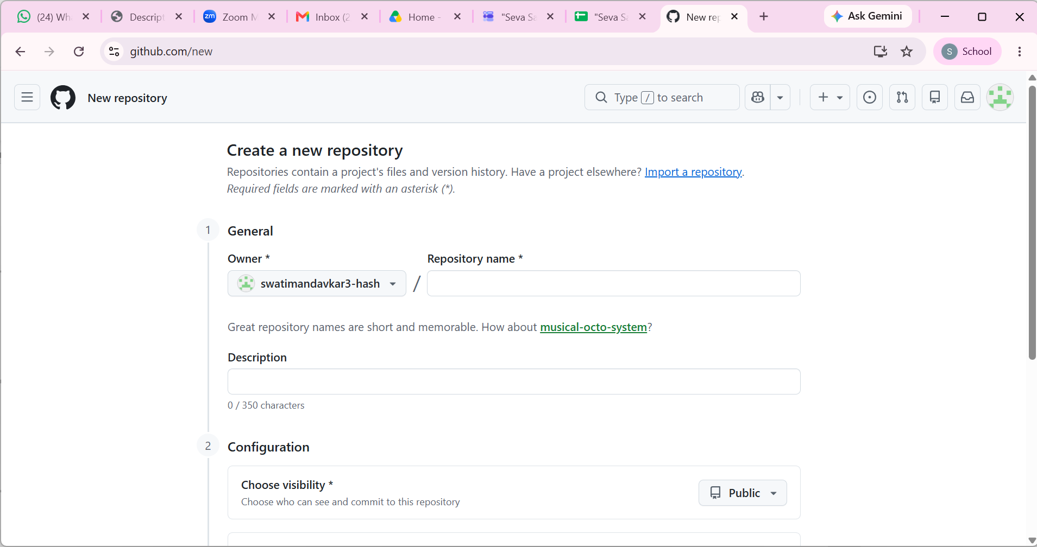
For a normal project website, you can use a name such as:
my-website
If you want a personal/user site, GitHub uses the special repository name:
YOUR-USERNAME.github.io
For example, if the GitHub username is student123, the repository would be:
student123.github.io
GitHub documents user sites and project sites as separate types. GitHub Docs

Step 3: Upload Your Files

Open your newly created repository.
Choose:
Add file → Upload files
Upload:
index.html
style.css
script.js
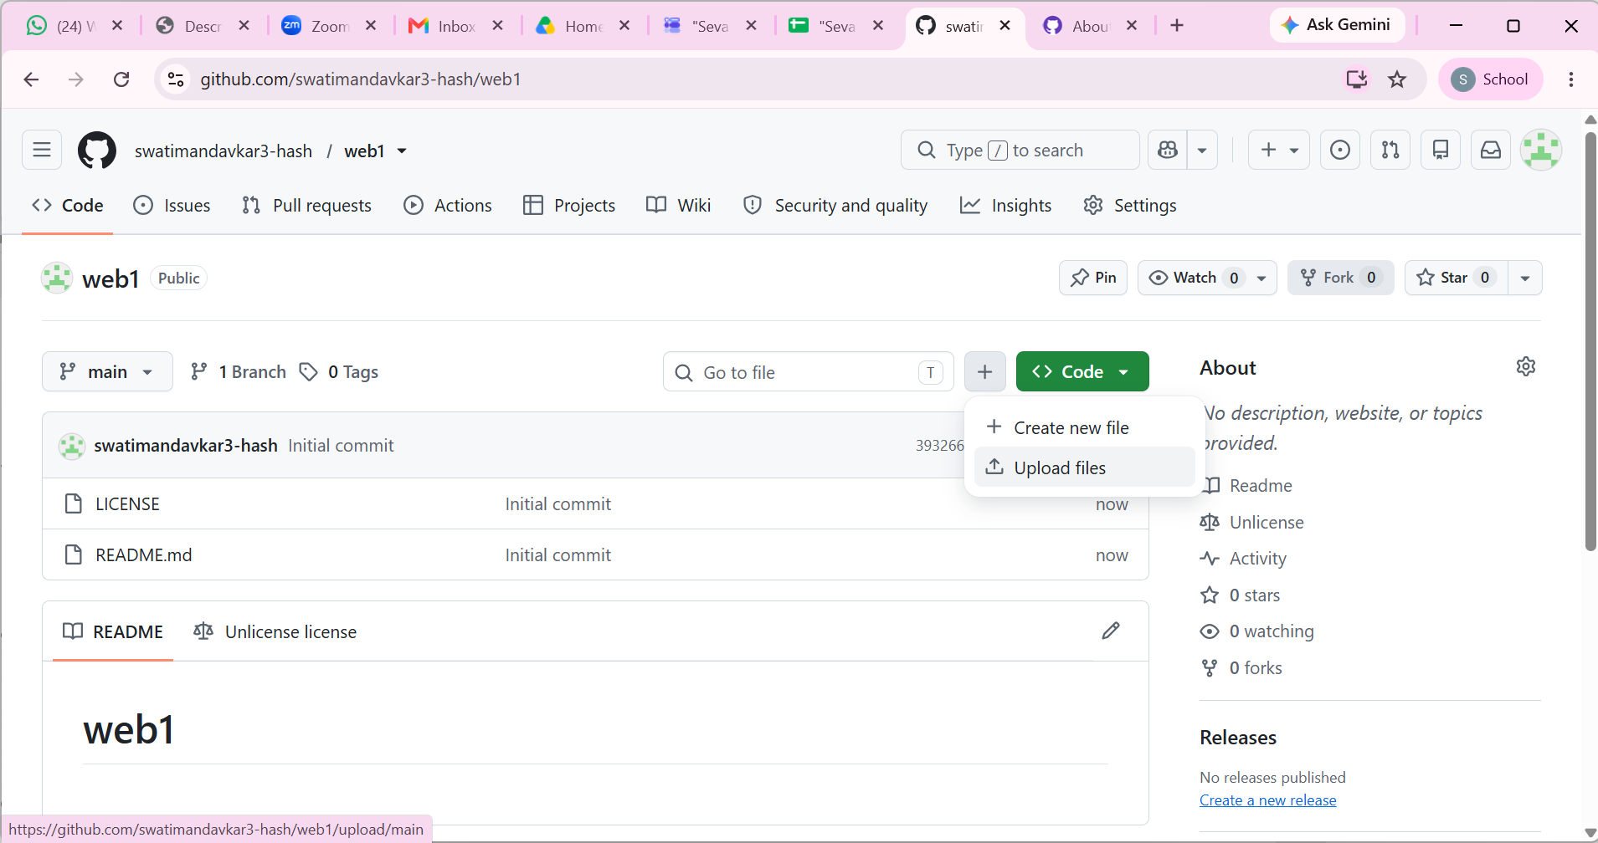

Then click Commit changes.
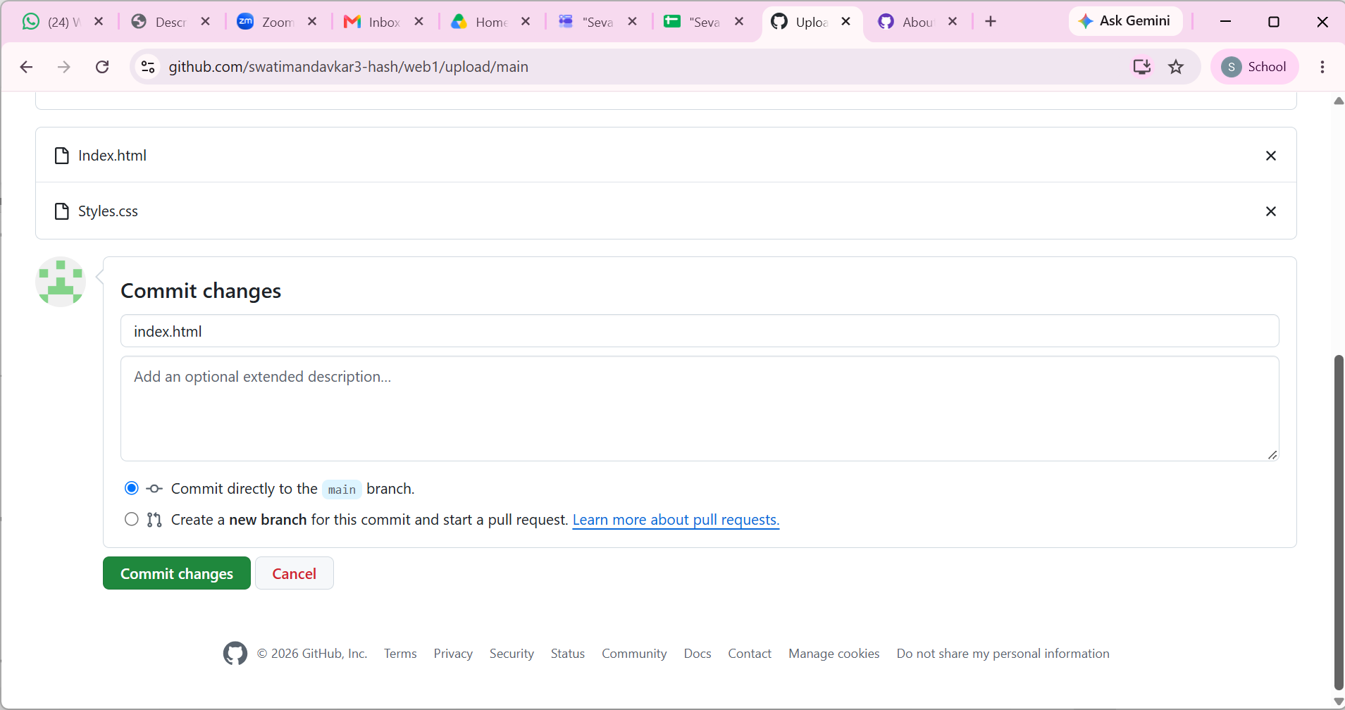

Step 4: Enable GitHub Pages
Open your repository and go to:
Settings → Pages
Under Build and deployment:
Set Source to Deploy from a branch.
Select the main branch.
Select the / (root) folder.
Click Save.
GitHub officially supports publishing from a selected branch and either the repository root or /docs folder. GitHub Docs
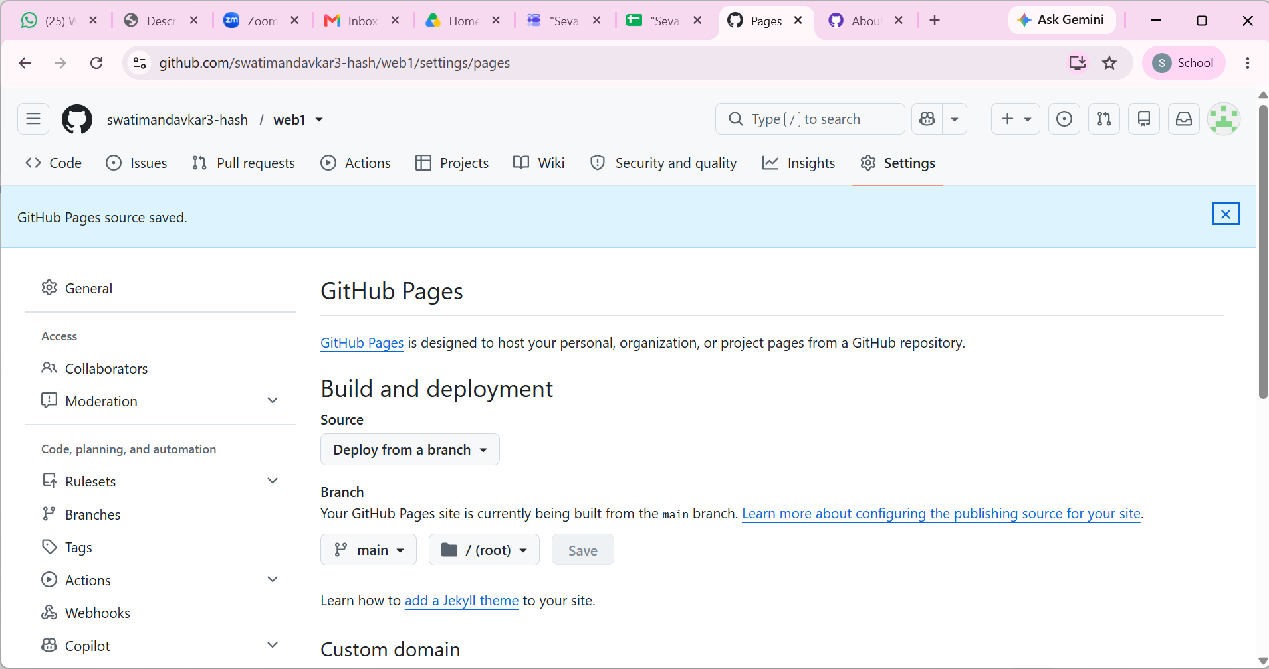
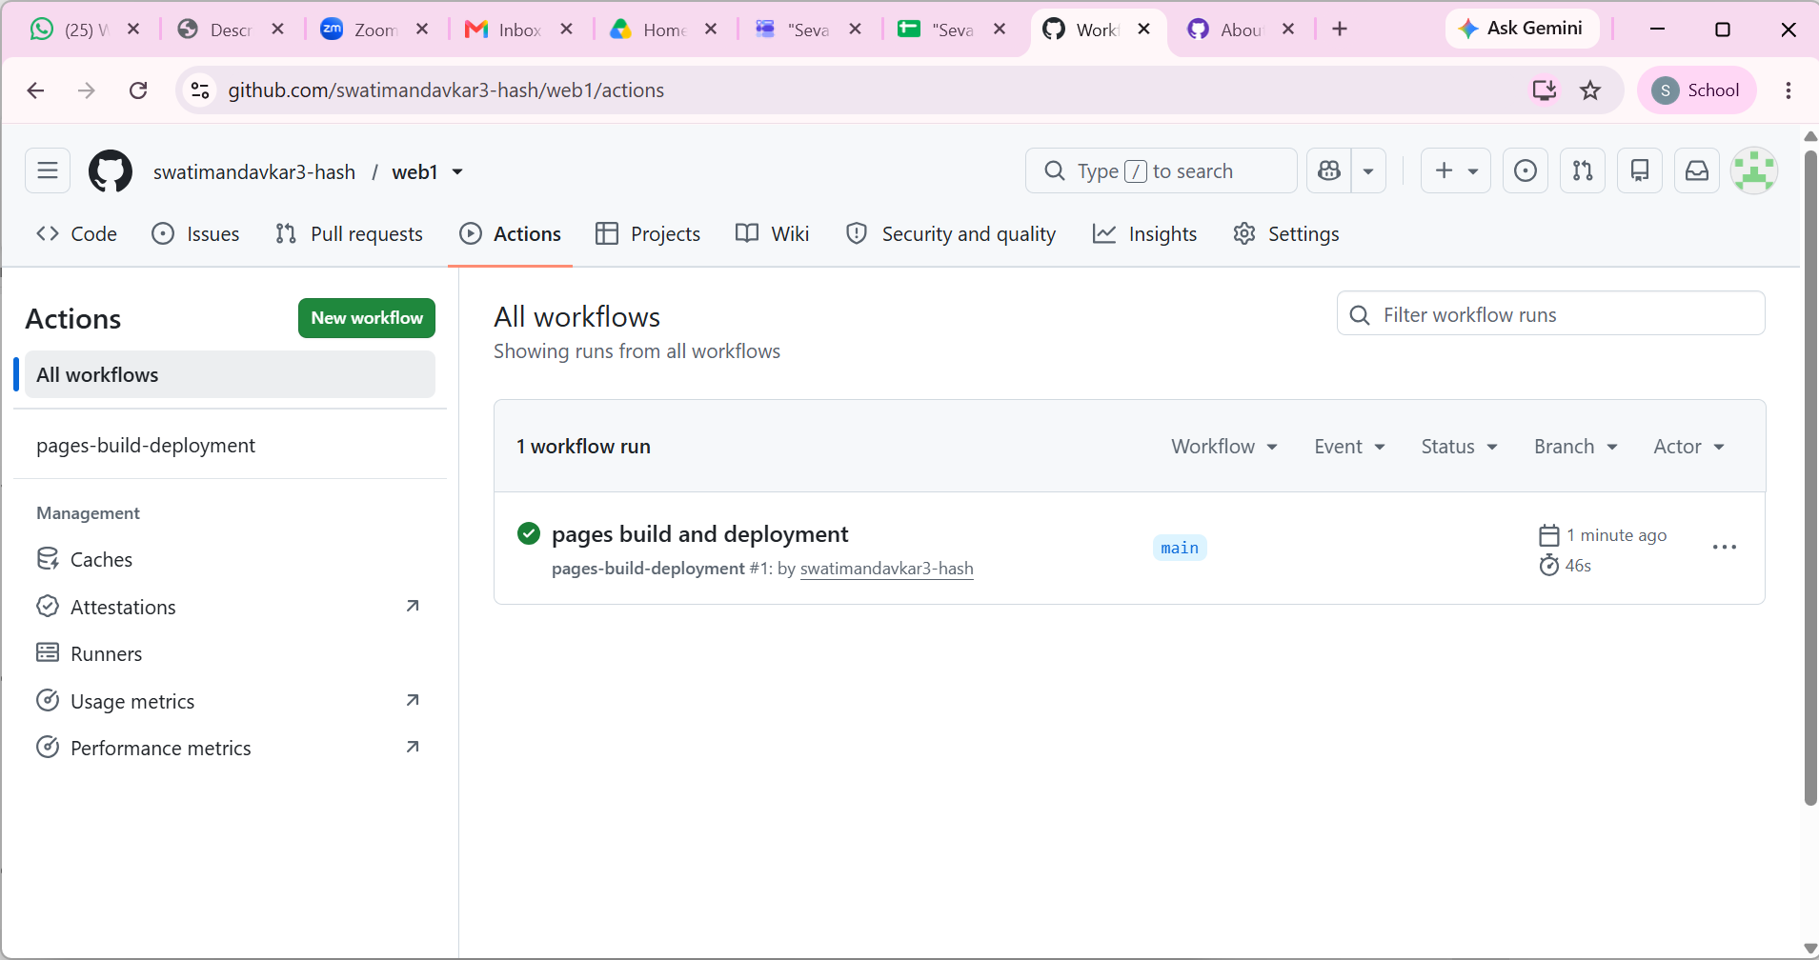
Step 5: Open Your Website

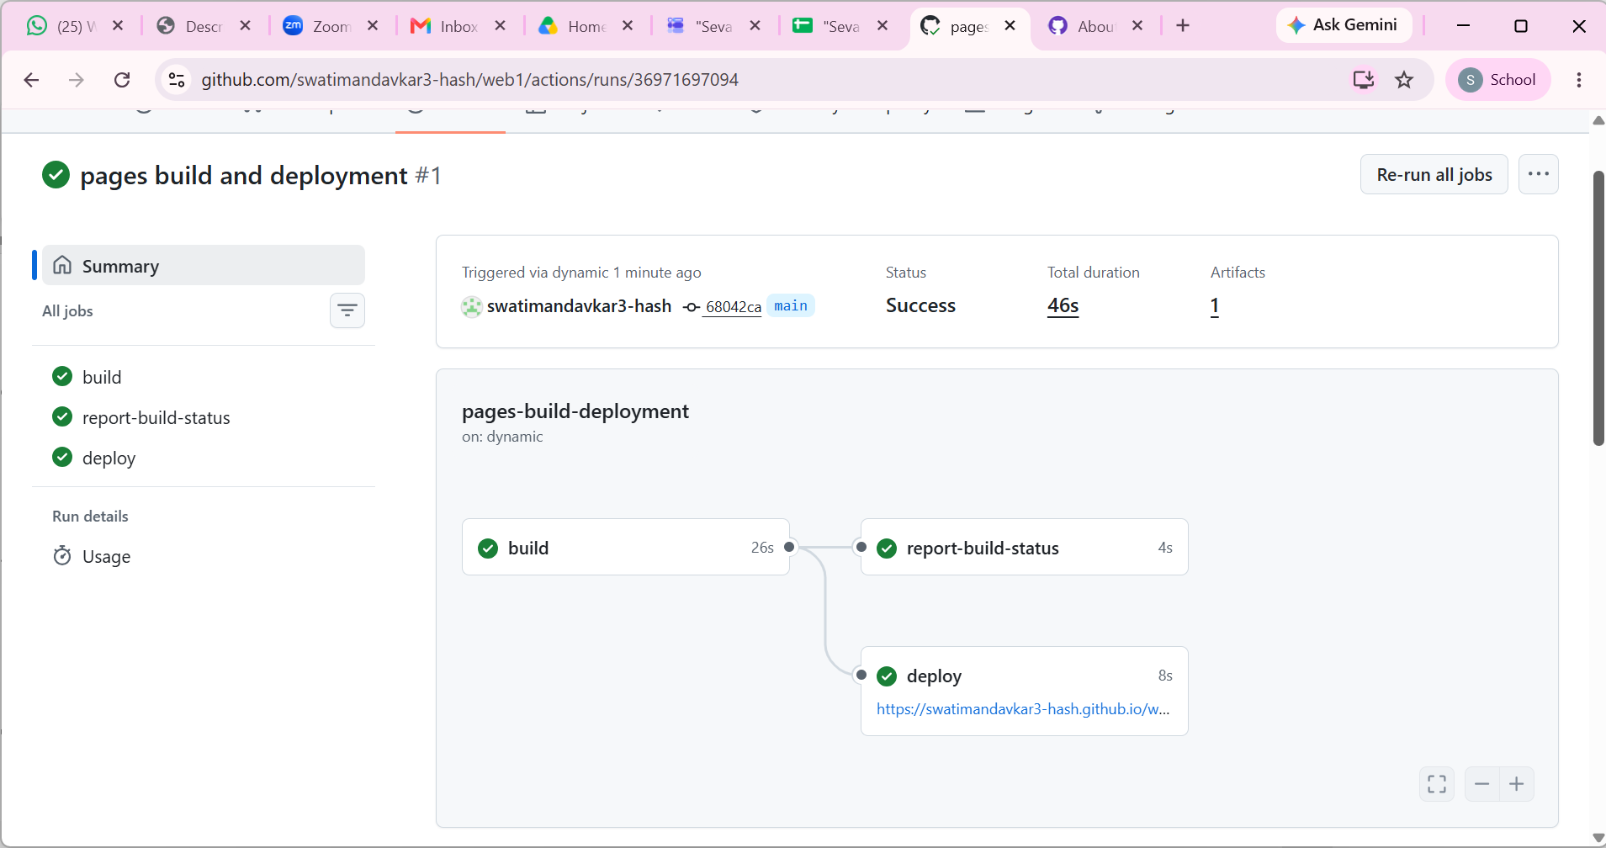
For a project repository named my-website, the usual URL is:
Step 6: Verify the Website
After enabling Pages, GitHub will build and deploy the website.
Go back to:
Settings → Pages
GitHub provides a Visit site option once the site is published. GitHub Docs
The first deployment can take up to about 10 minutes to become available. GitHub Docs
Updating the Website
Whenever you modify your website:
Edit files
↓
Upload/commit changes
↓
GitHub repository updated
↓
GitHub Pages redeploys
↓
Updated website becomes live

